**S3 Basic configuration, Versioning & Static website hosting**

1. **S3 Basic configuration**

Click “S3”.

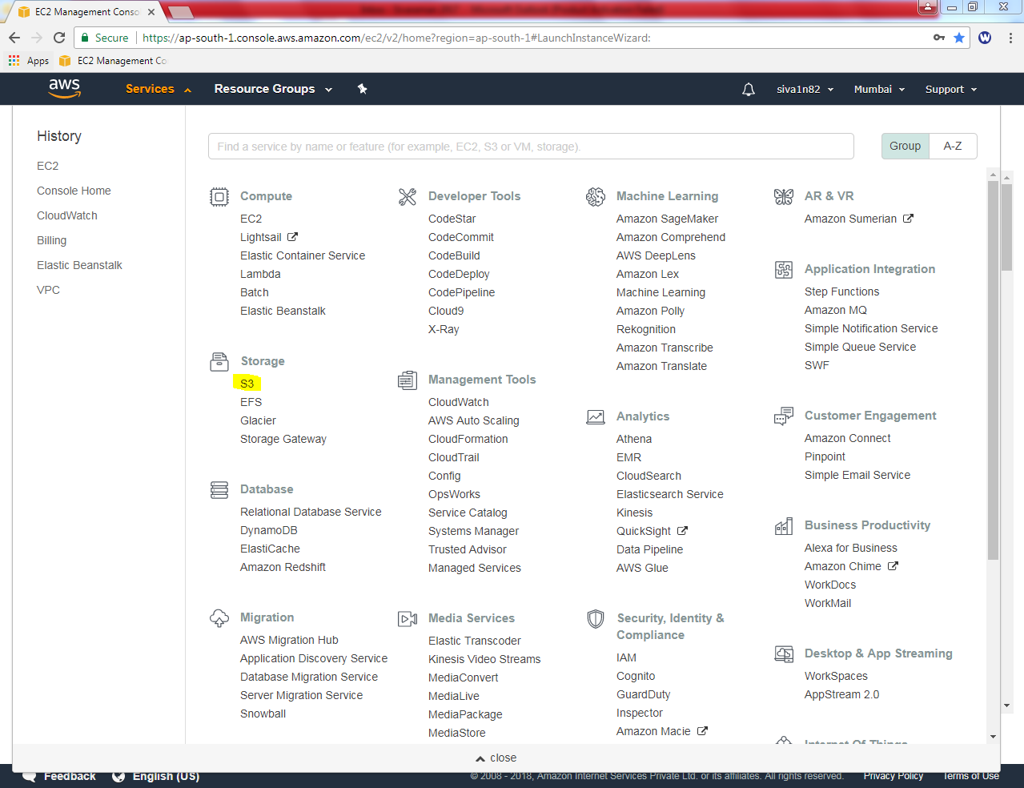

Click “create bucket”

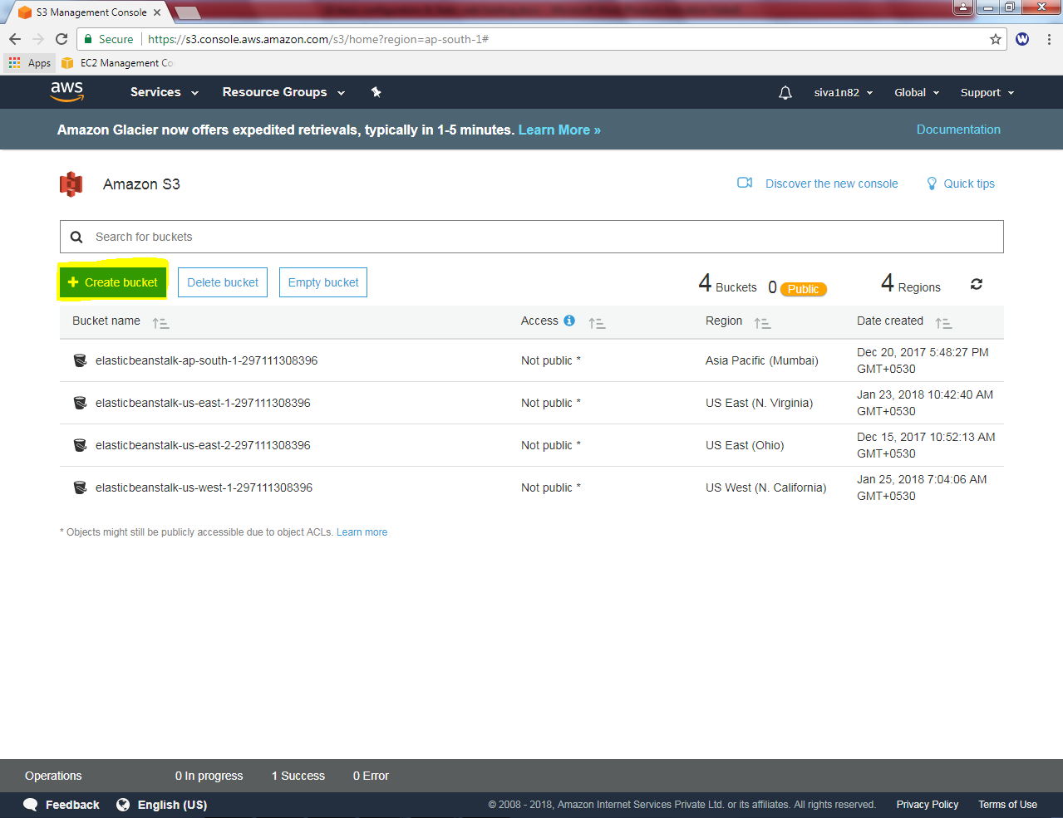

Type bucketname as “sansbound2017” and click “Next”.

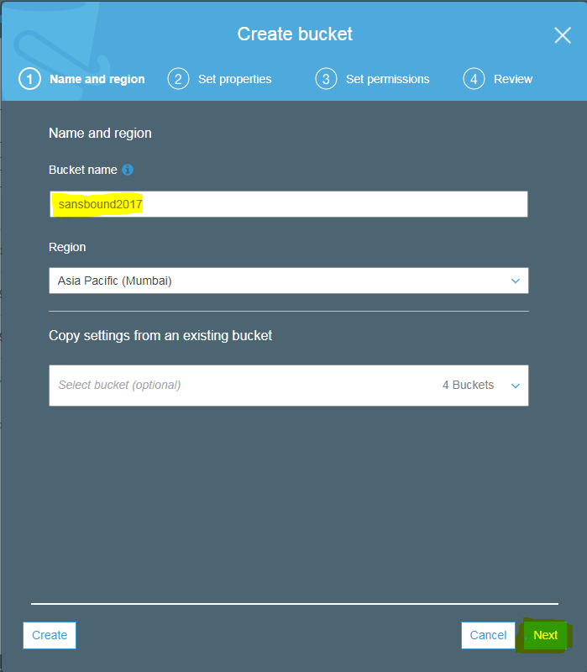

Leave the settings by default and click “Next”.

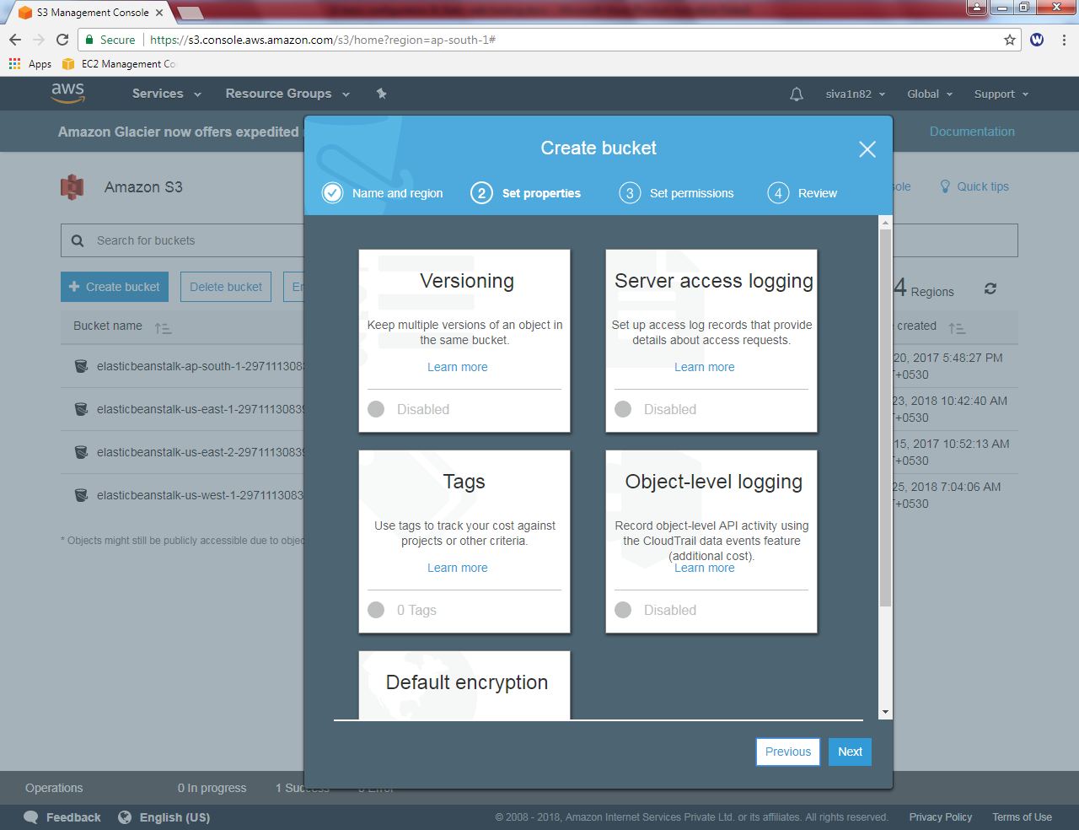

In Manage public permissions, click “Do not grant read access to this bucket” drop down button.

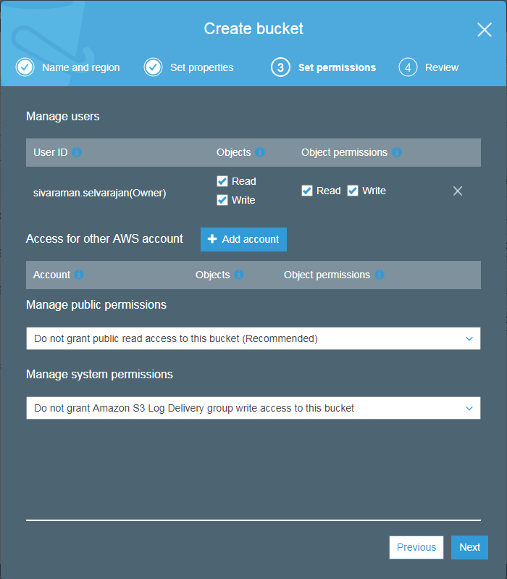

Click “Grant public read access to this bucket”.

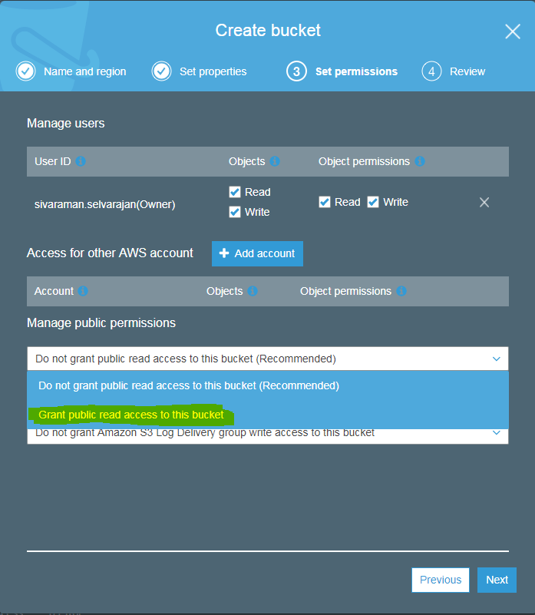

Click “Next button.

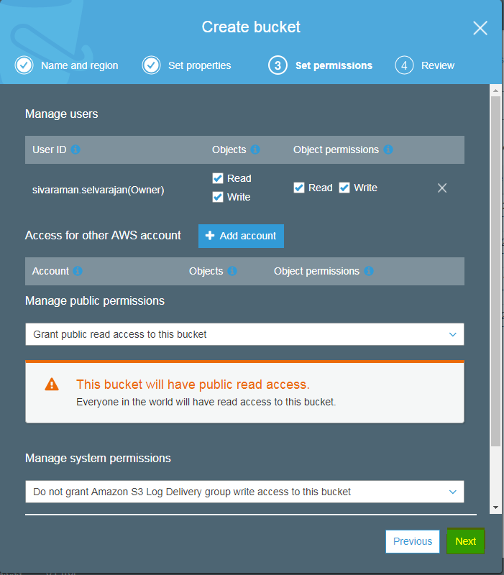

Review the configuration and click “Create bucket”.

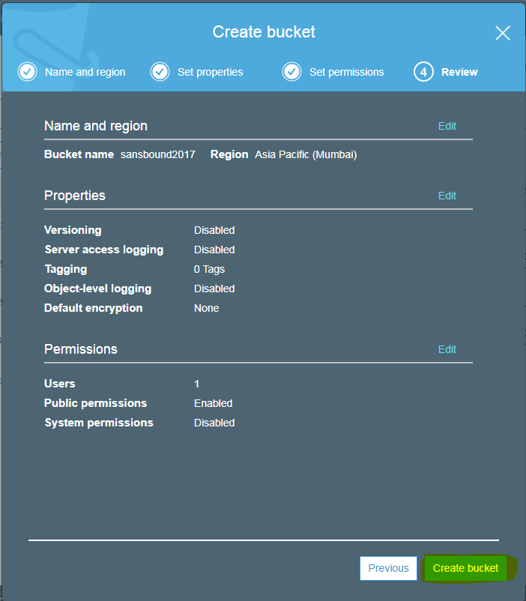

You can able to see that bucket is publicly accessible. Click “Sansbound2017” bucket.

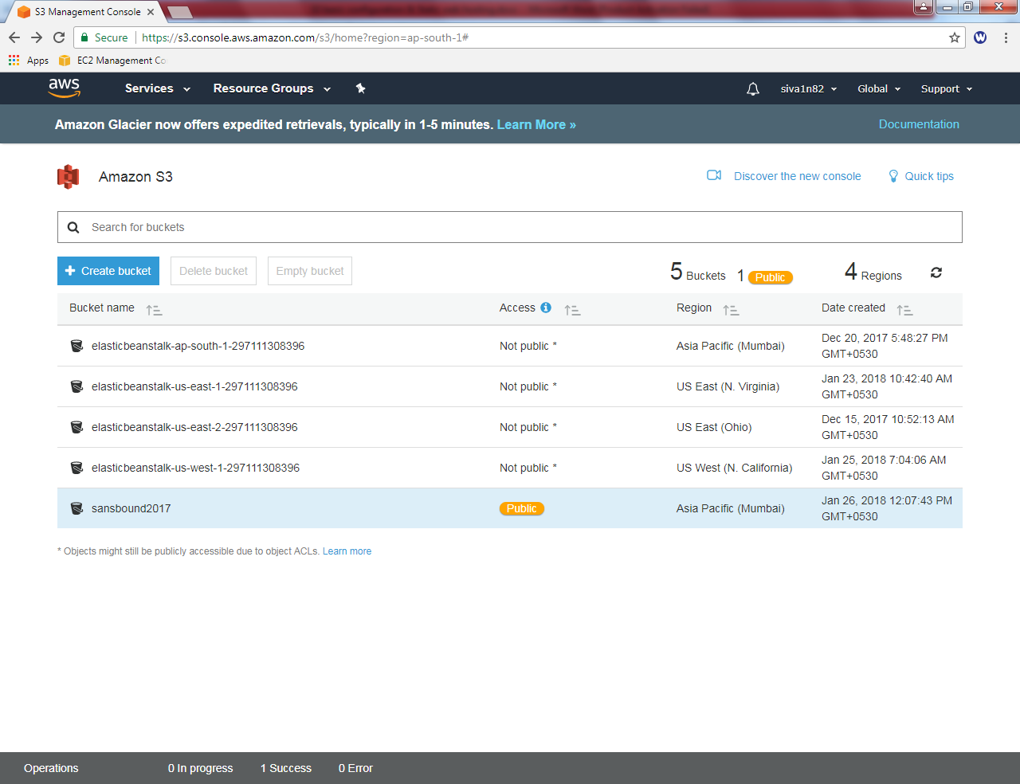

Click “Upload” button to upload your files.

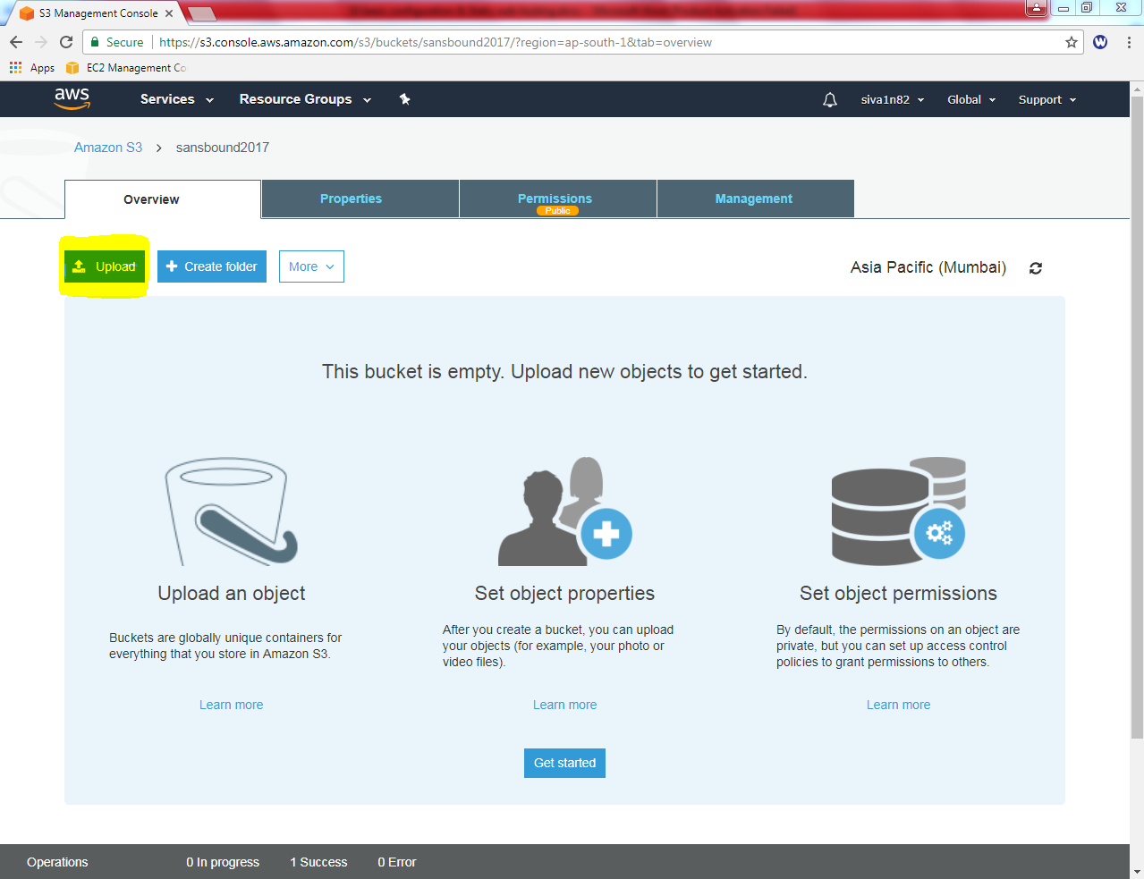

Click “Add files” to add files into bucket.

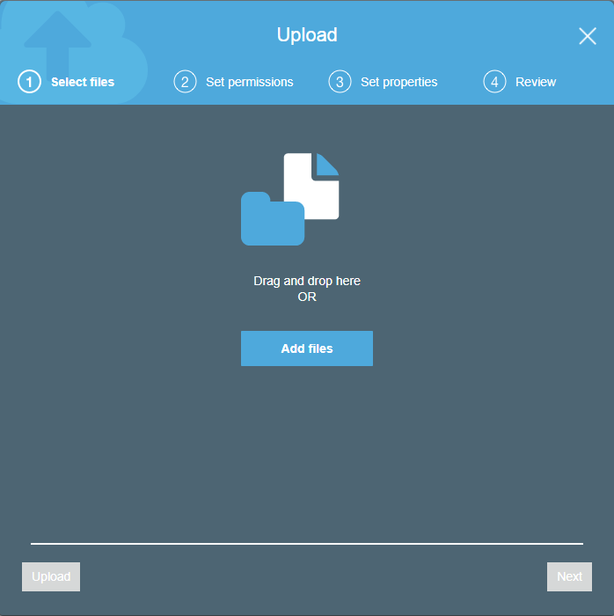

Browse and locate the “Republic day.jpg” file and click open.

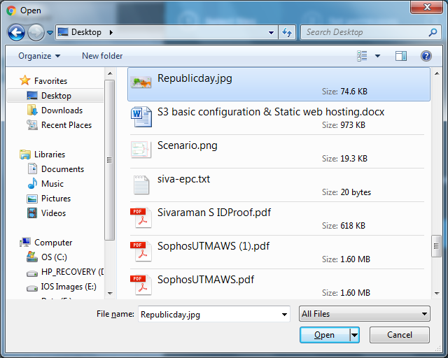

Click “Upload”.

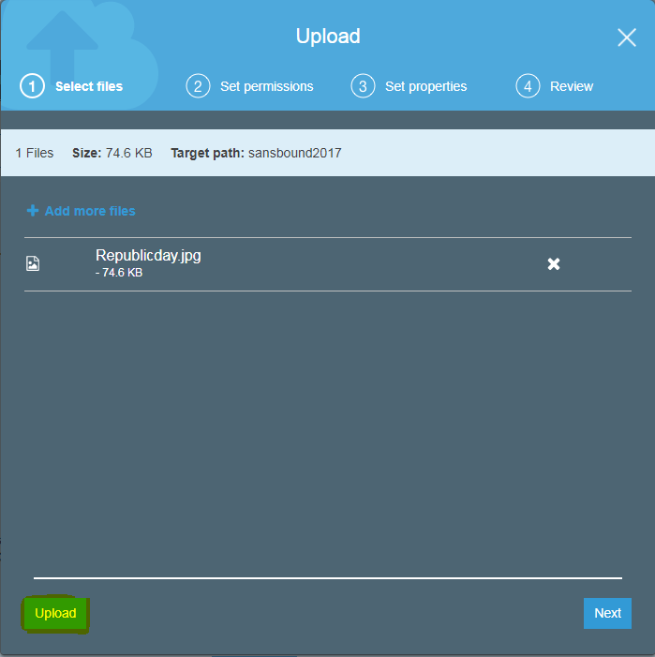

Click the “Republicday.jpg” file to get the URL path.

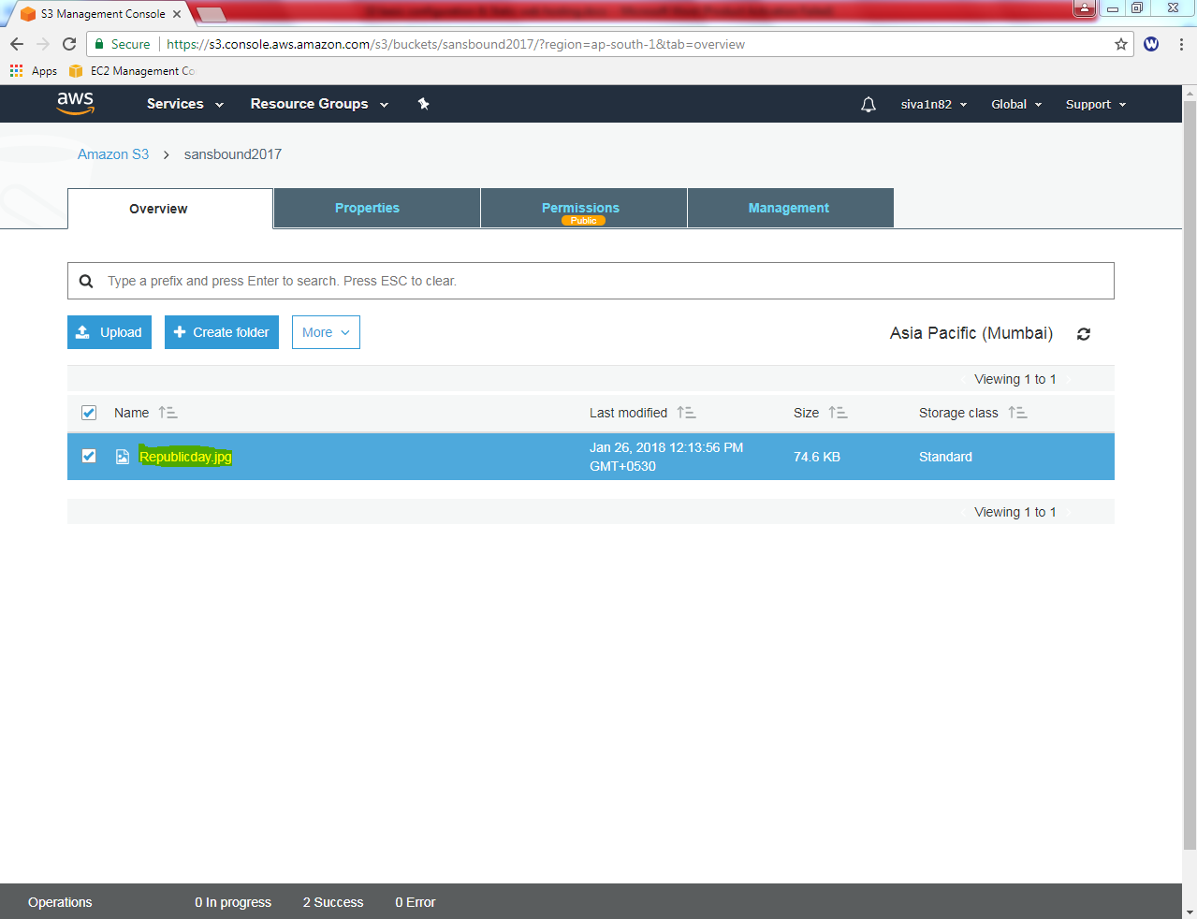

You can able to see the URL path of Republicday.jpg object/file.

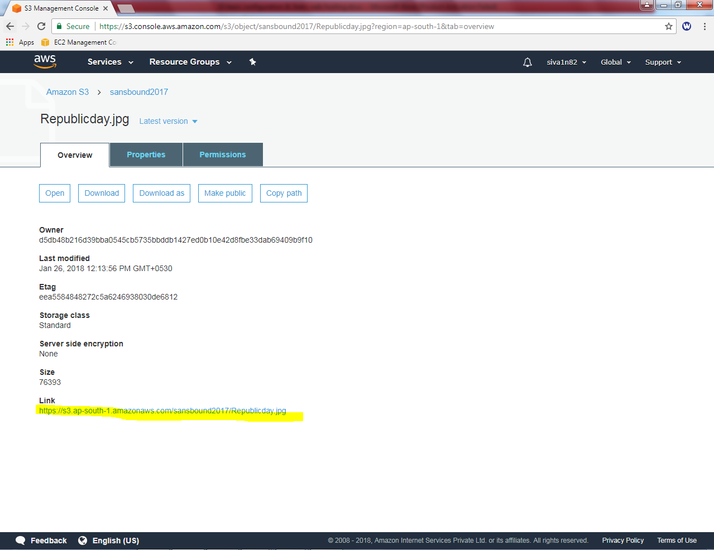

You need to provide public access to the object / file.

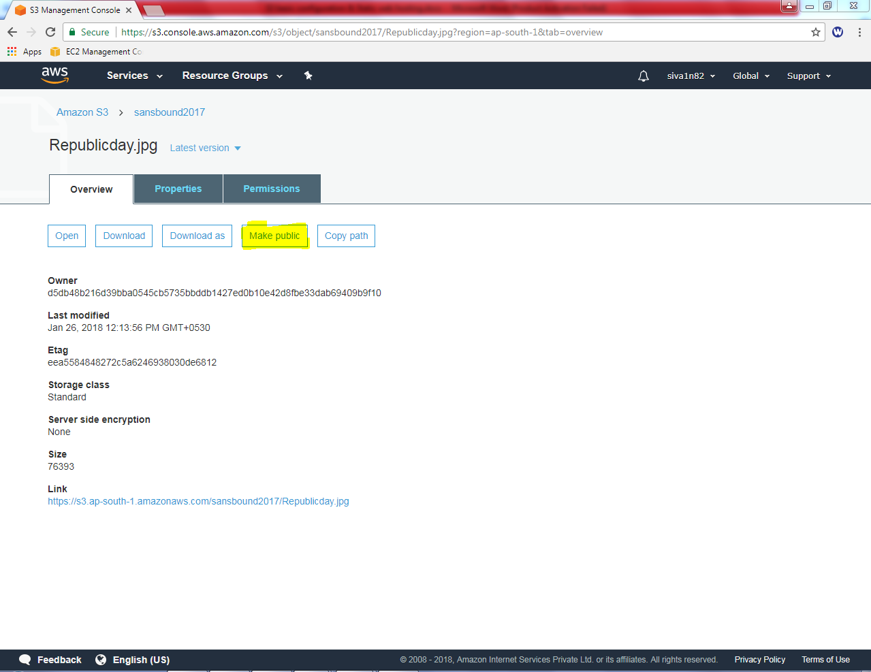

Click make public. You have got success information.

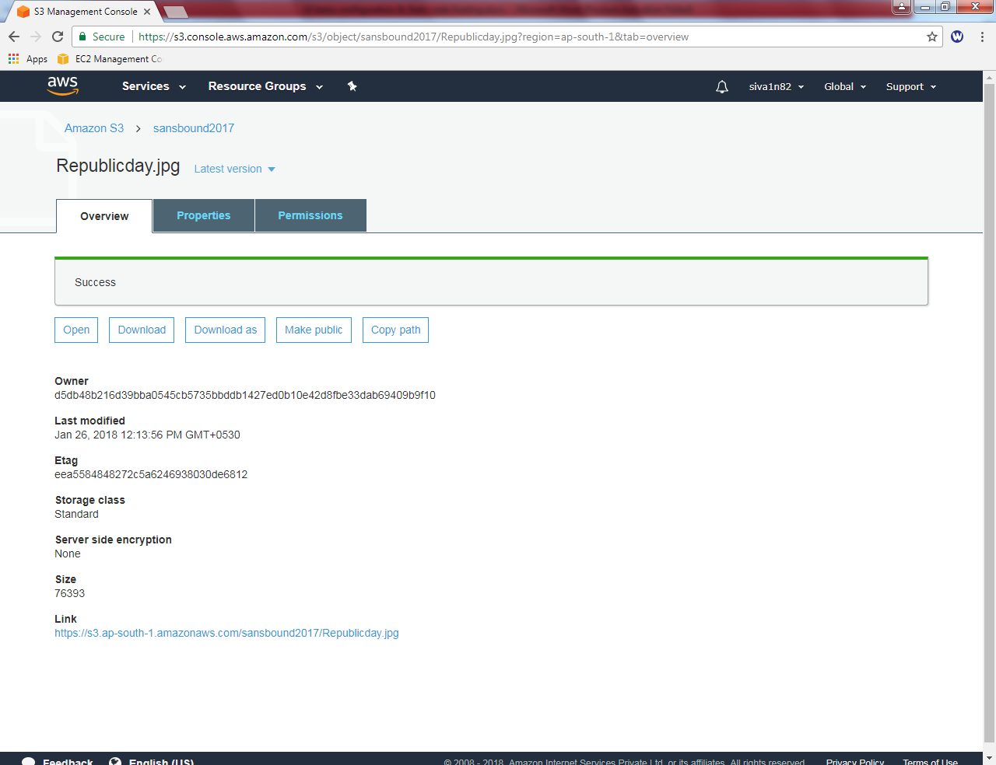

Try to connect the bucket from internet. We have got the image successfully.



1. **Enable versioning**

Click “s3” and then click “Create Bucket”.

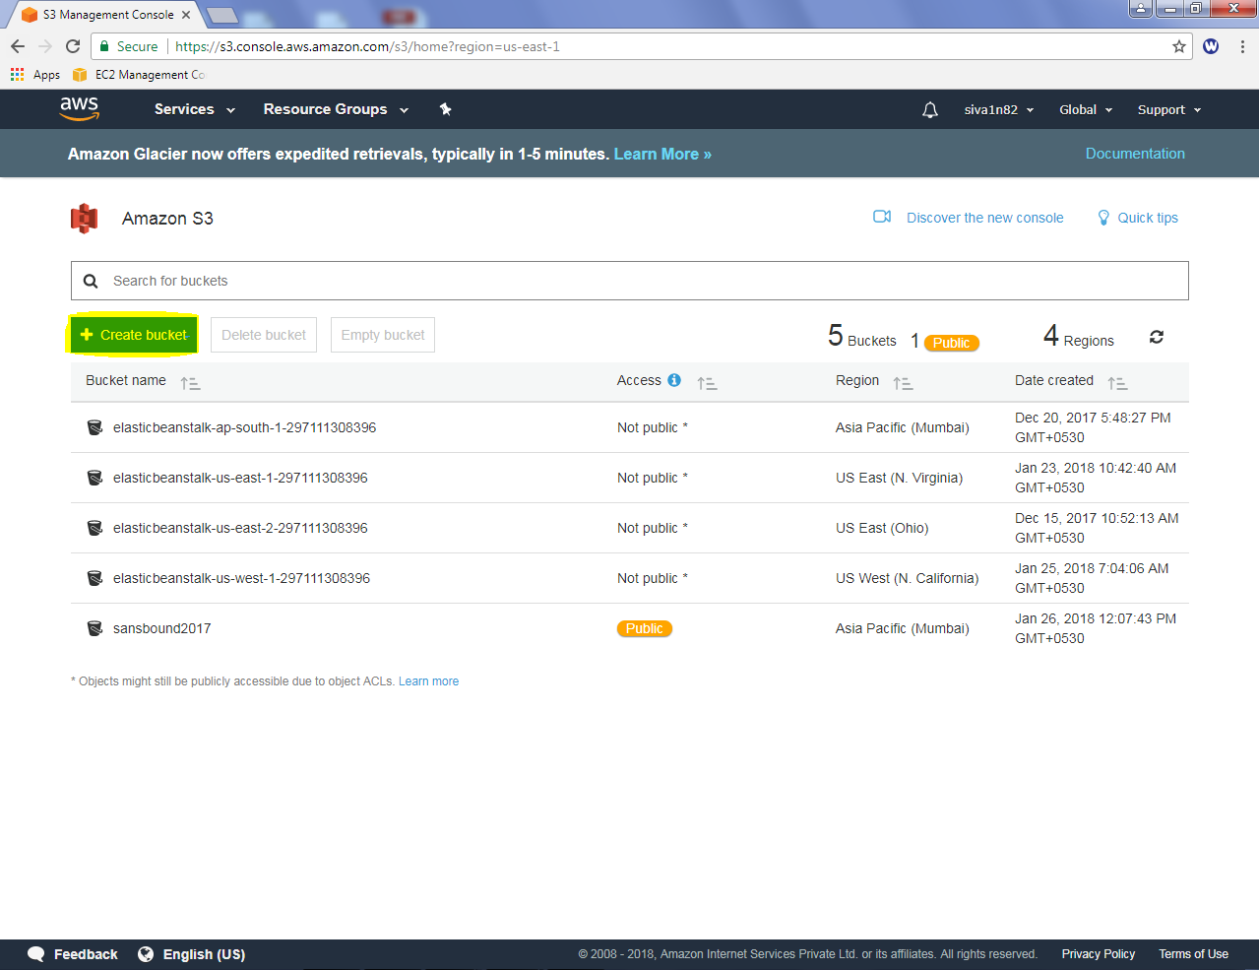

Type bucket name as “Sansbound-versioning” and click “Next”.

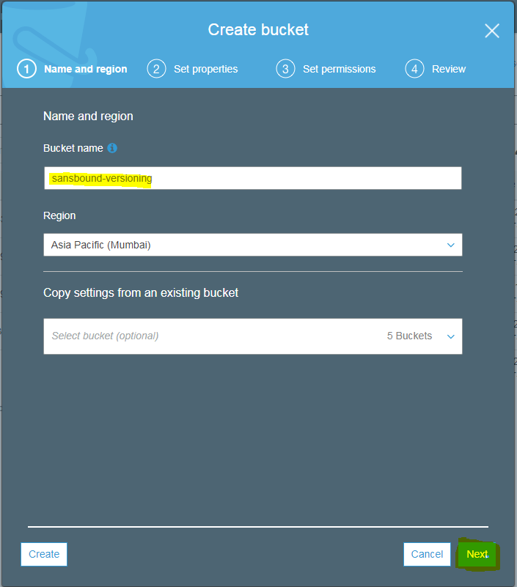

Click “Versioning”.

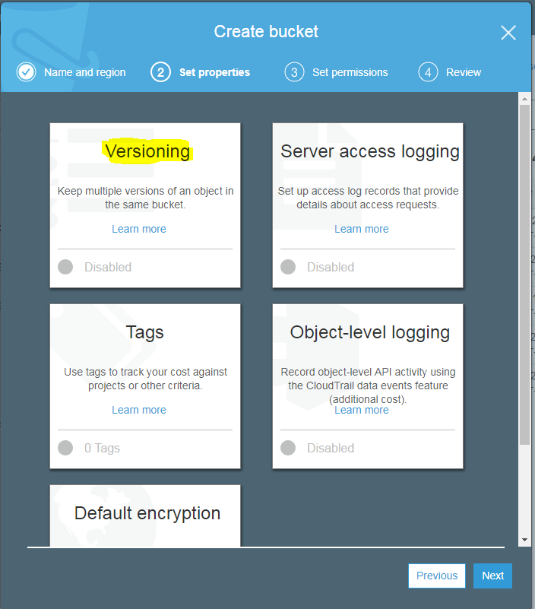

Click “Enable versioning” and click “save”.

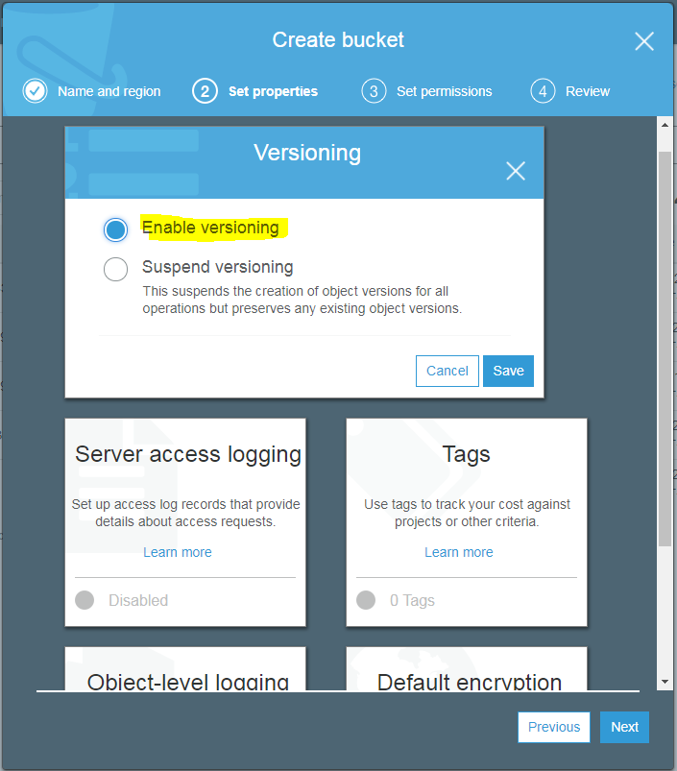

You can able to see versioning is enabled.

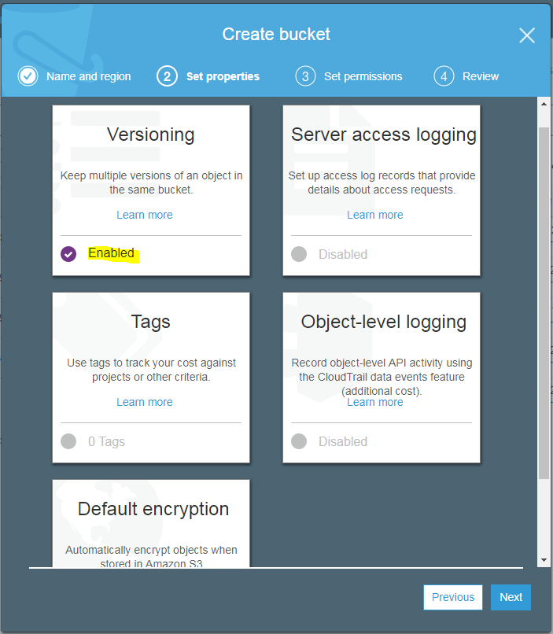

Leave the settings by default.

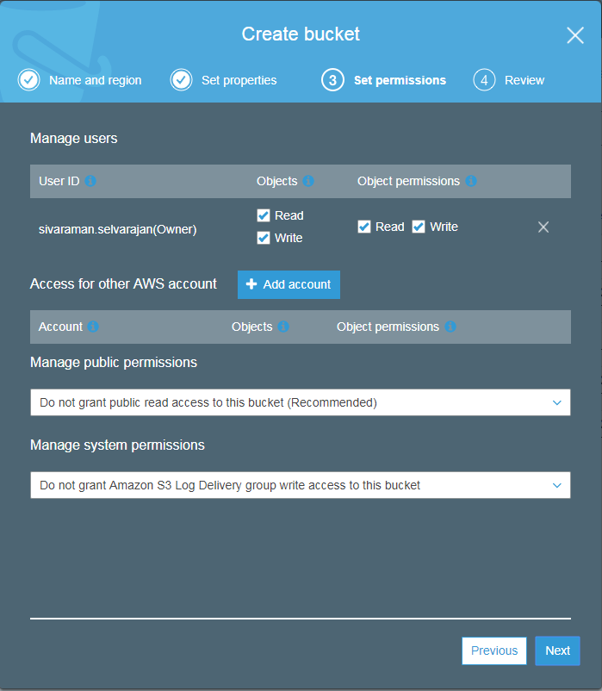

Review and click “Create Bucket”.

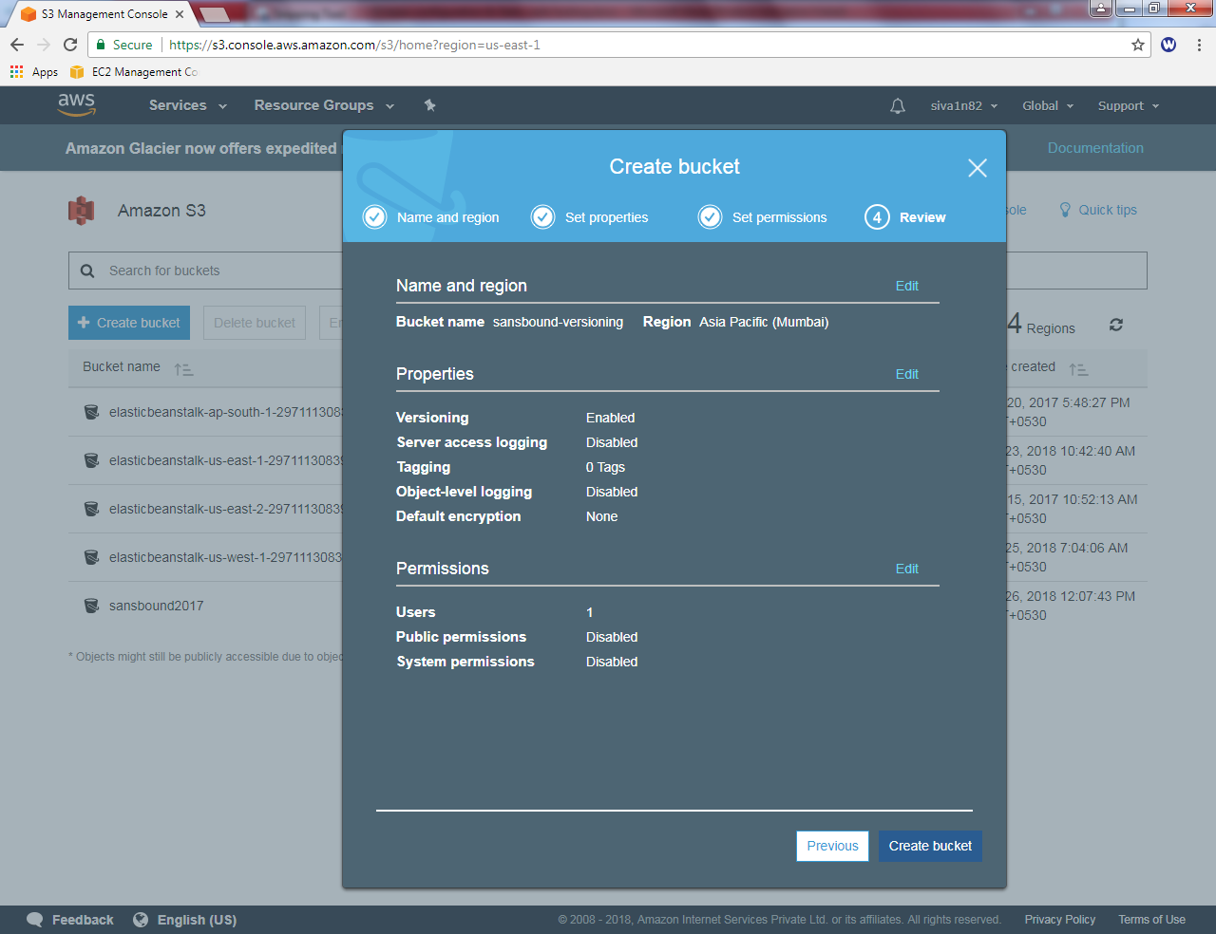

Click “Sansbound Versioning” bucket.

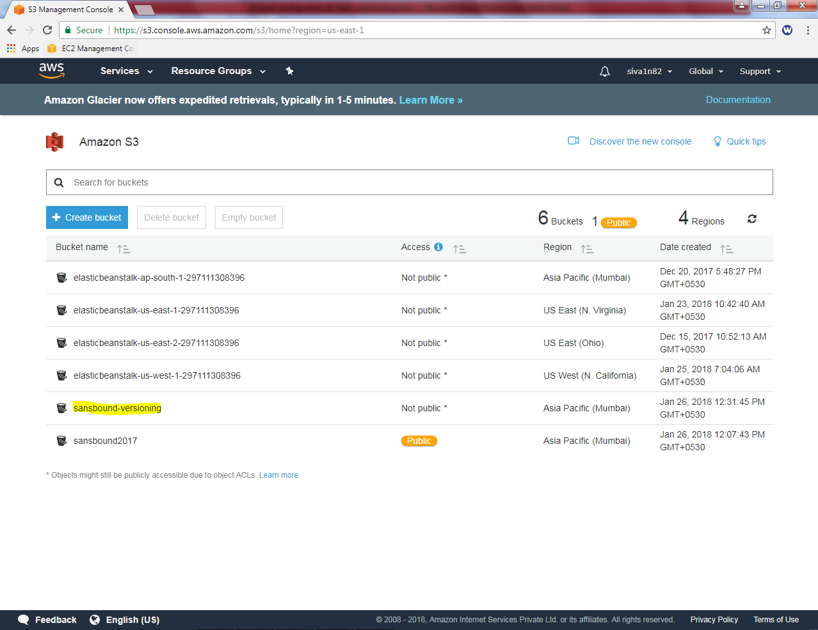

Click “Upload”.

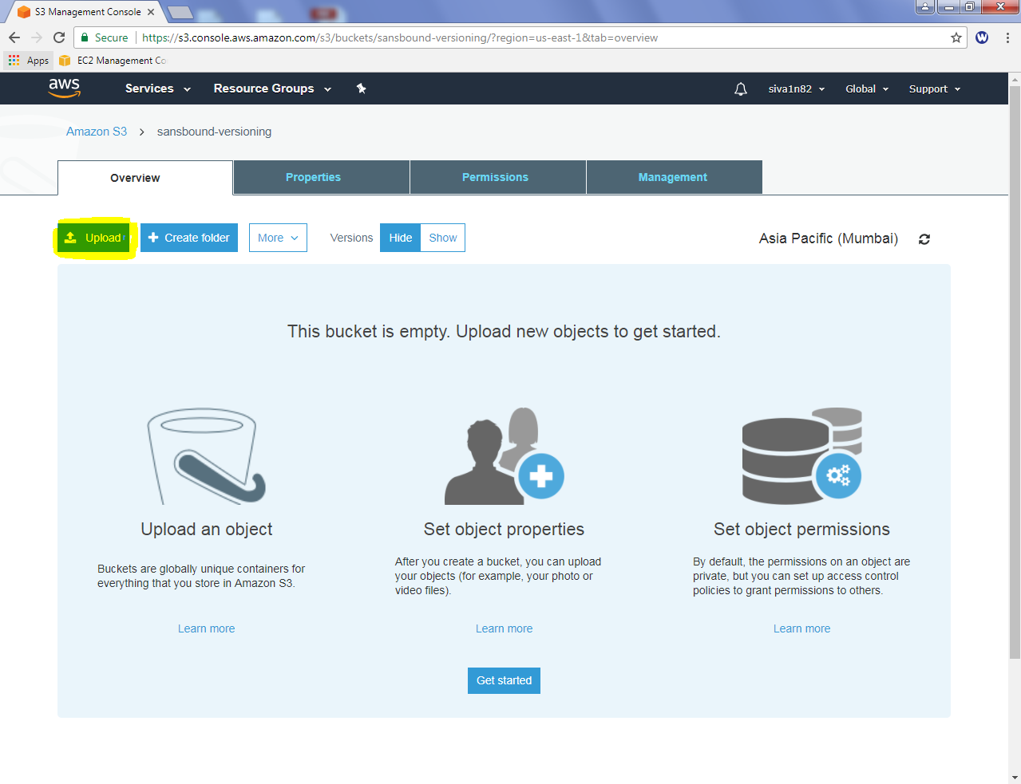

Click “Add files”.

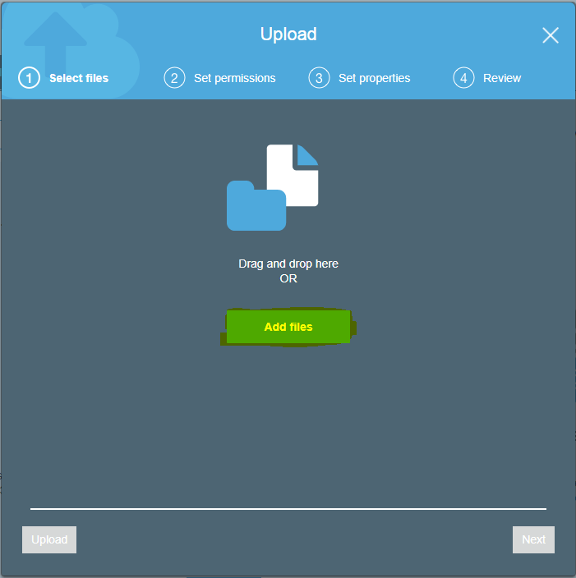

Locate the file sansbound.txt

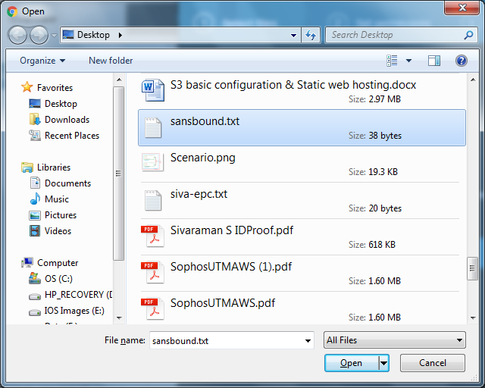

Click “ Open”.

Click “Upload”.

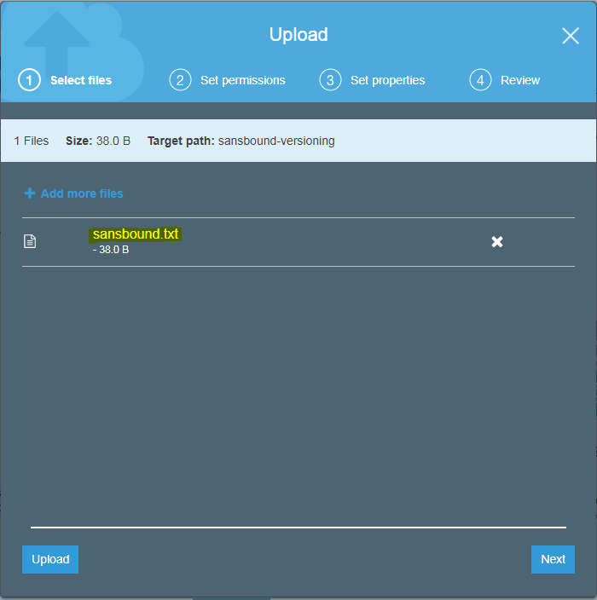

File has been successfully uploaded. File size is 38.0 B

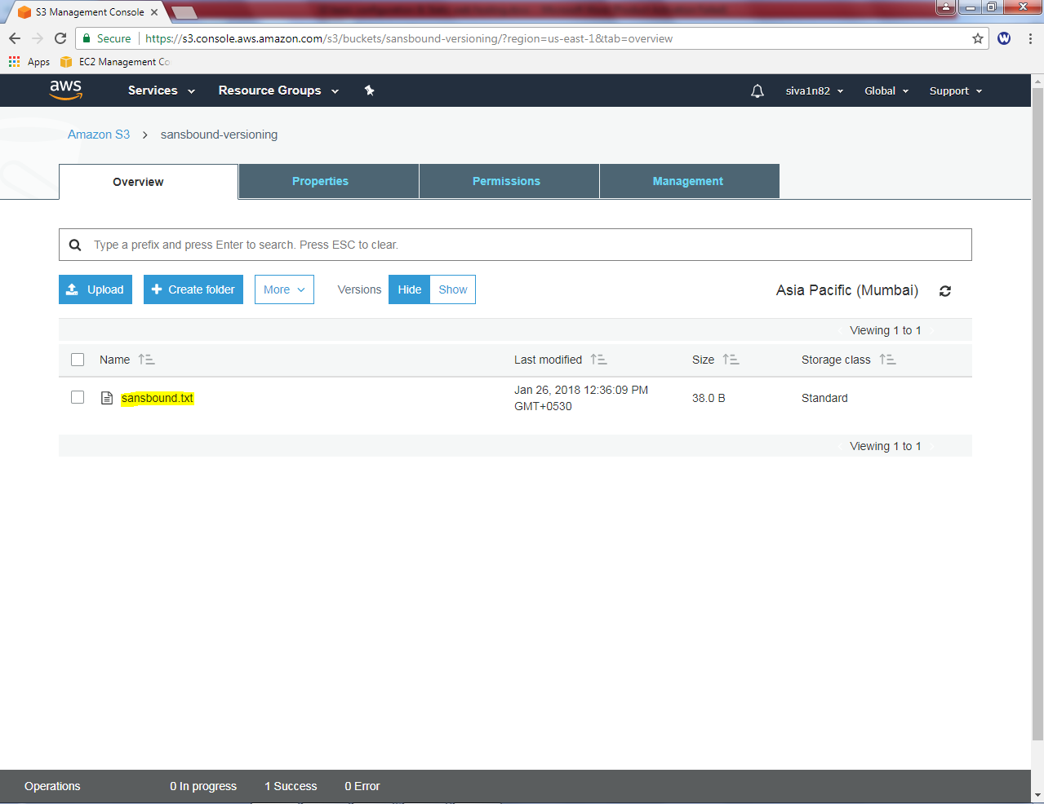

Modify the sansbound.txt file content in your location and need to reupload the same file.

Click “Upload”.

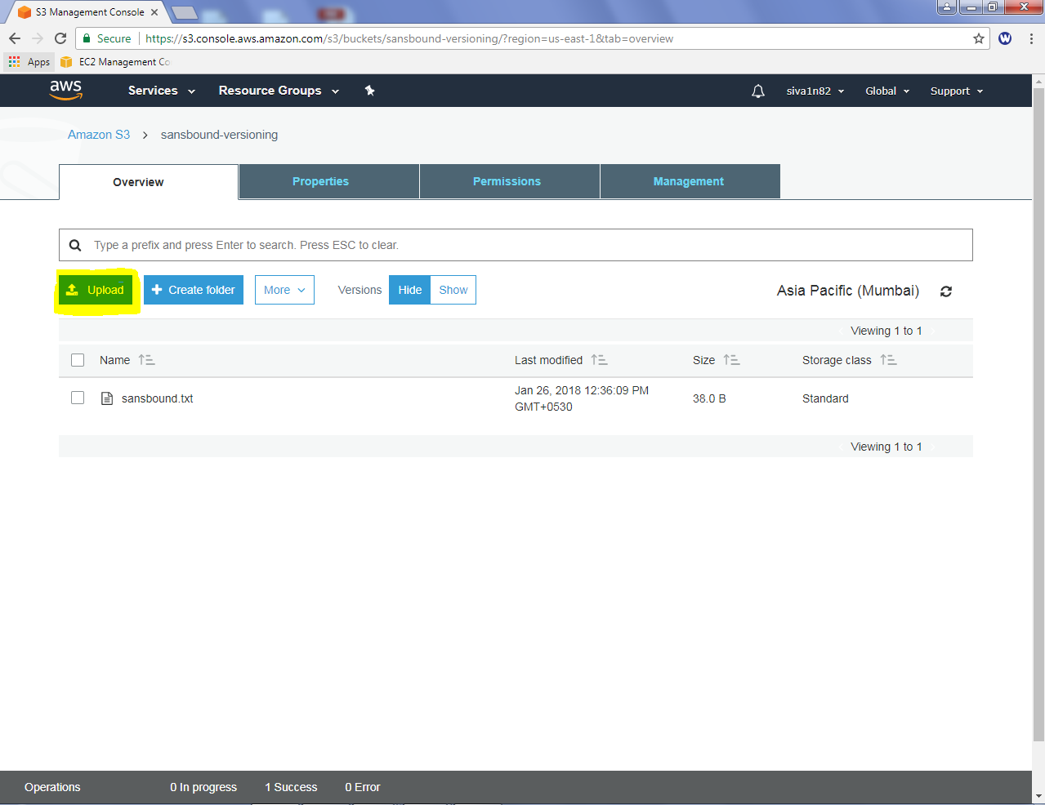

Click “Add files”.

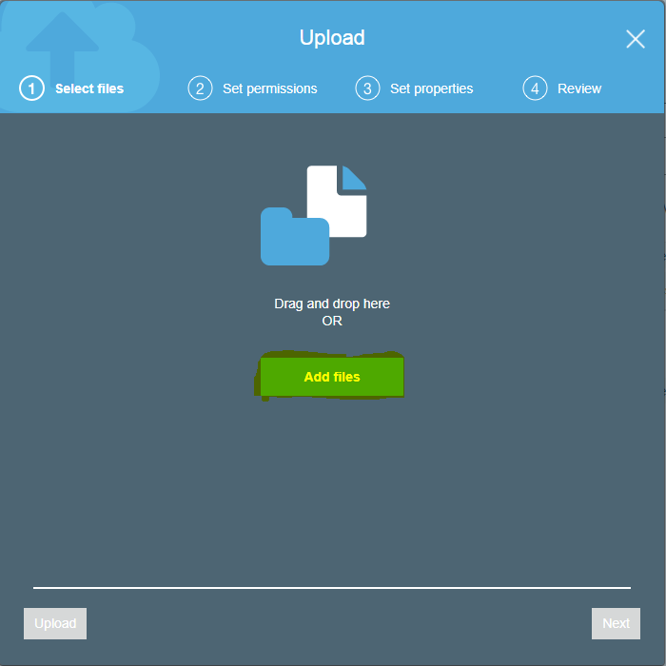

Locate the sannsbound.txt file and Click “Open”.

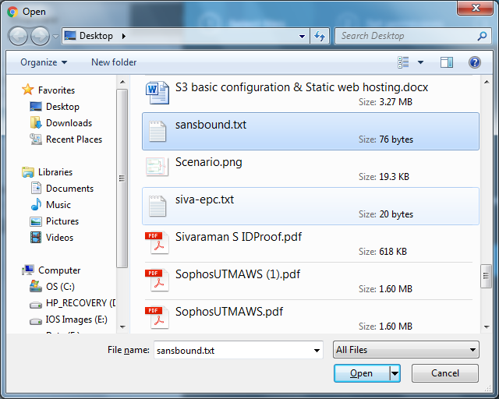

Click upload to reupload the updated / modified file sansbound.txt.

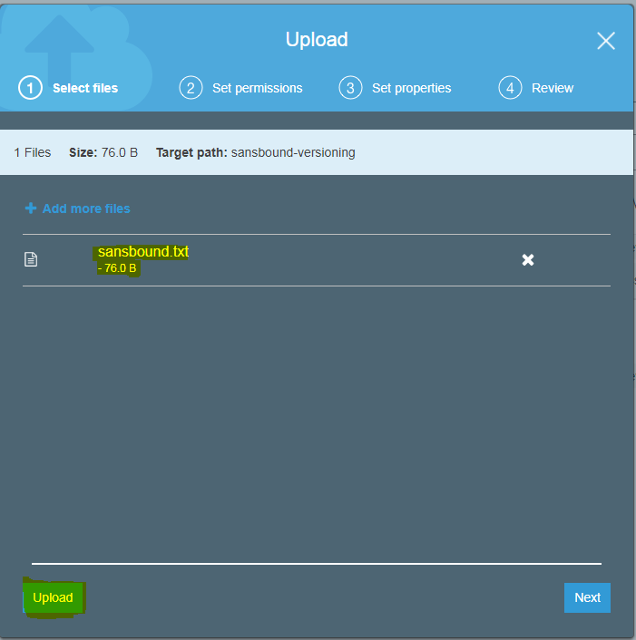

File has been successfully uploaded and file size is 76.0 Bytes.

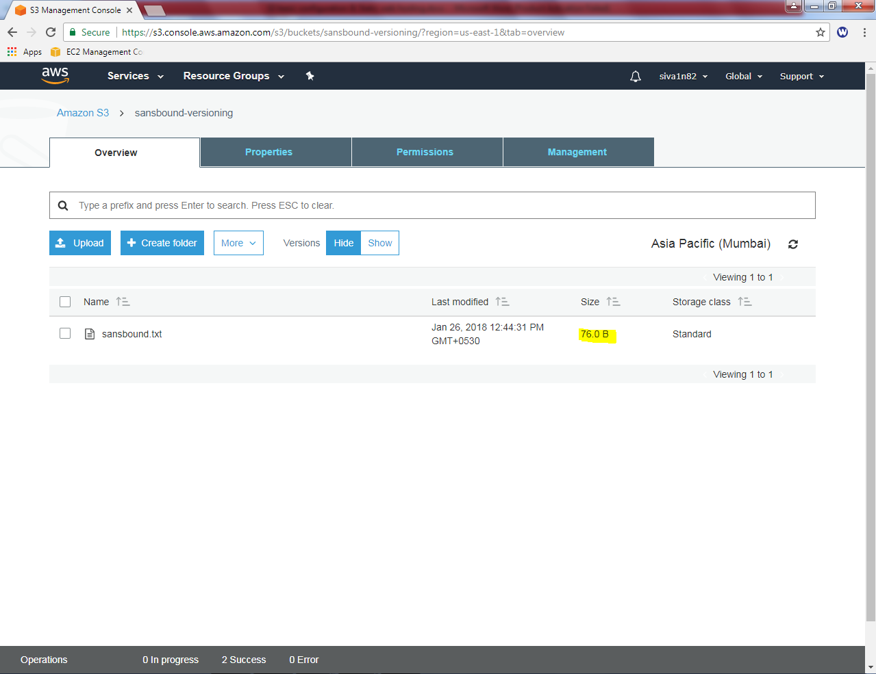

If you want to view the previous versions of the files, click “Show” button.

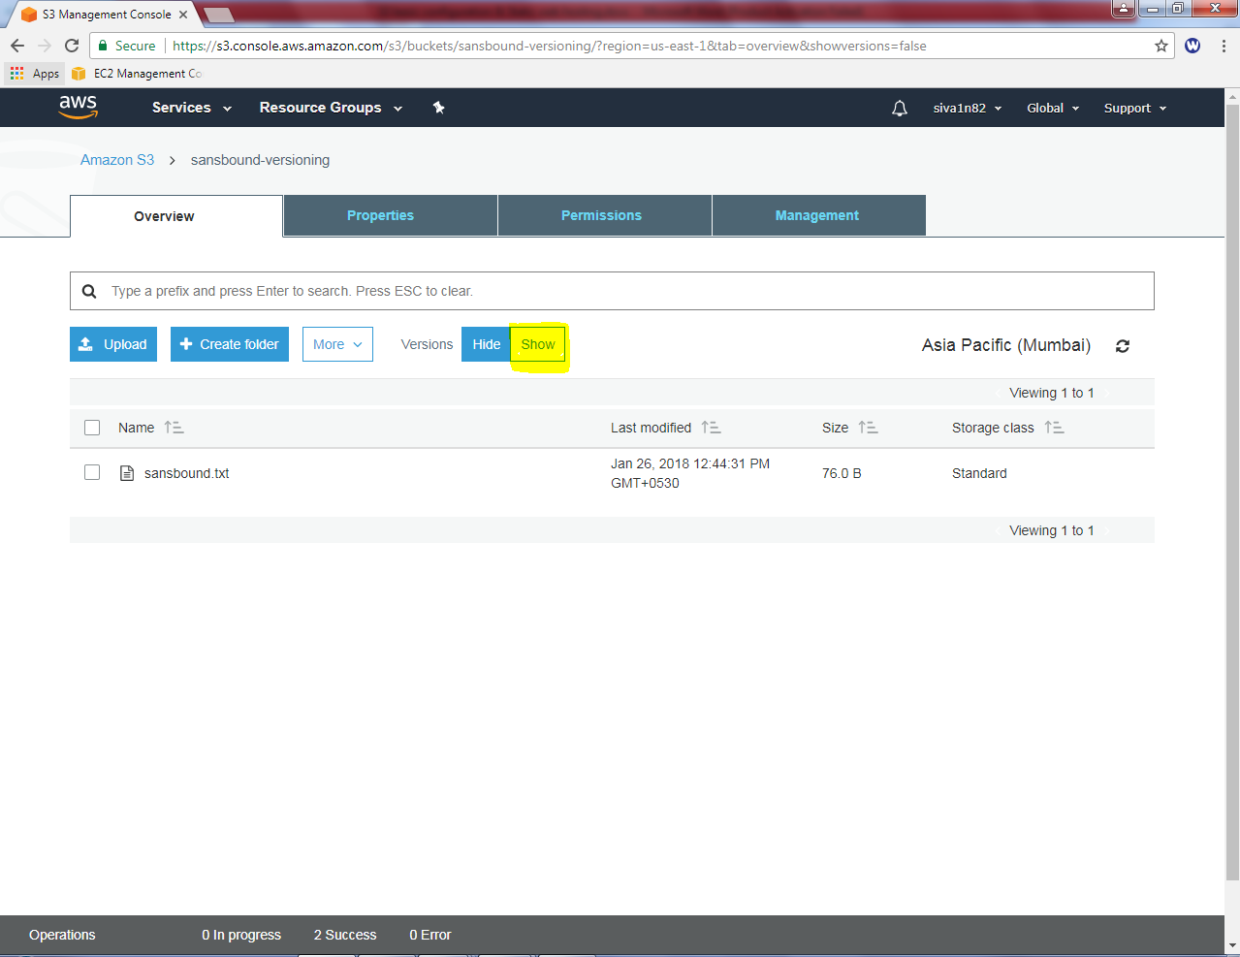

You can able to view the previous versions as below.

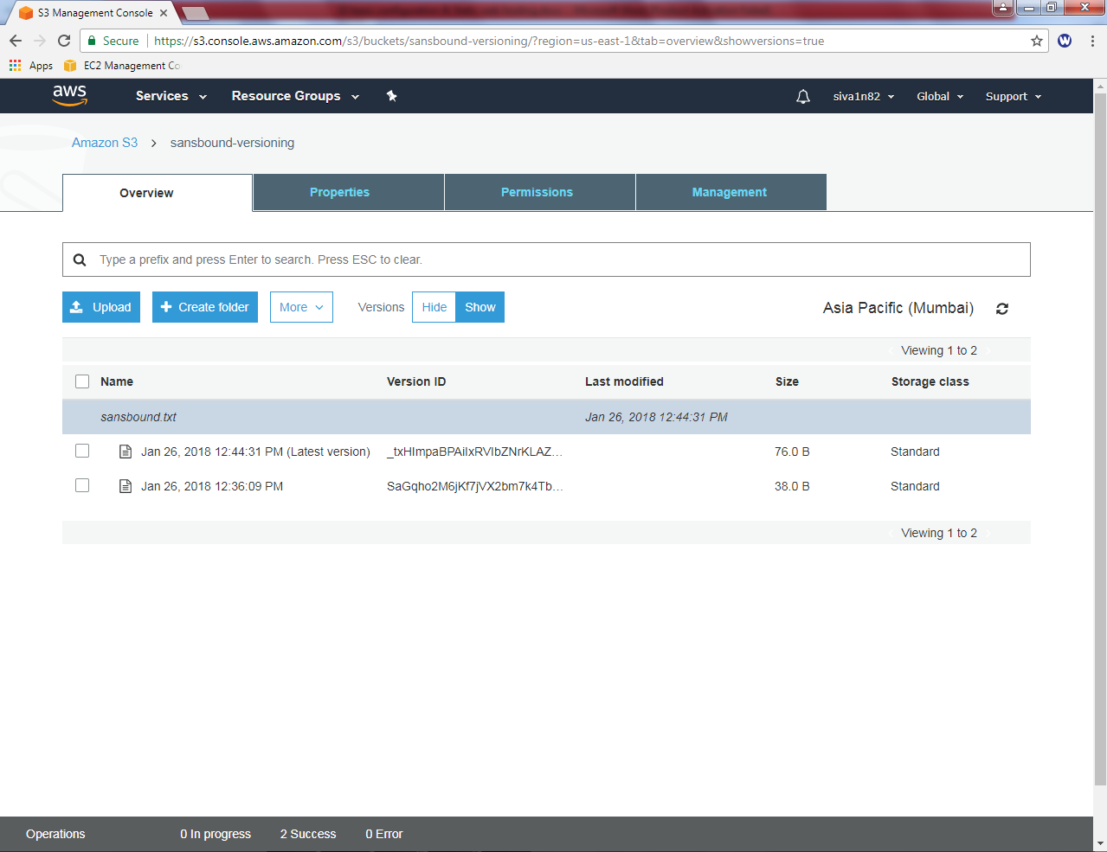

1. **Configure static web hosting:**

**In S3, click “ Create bucket”.**

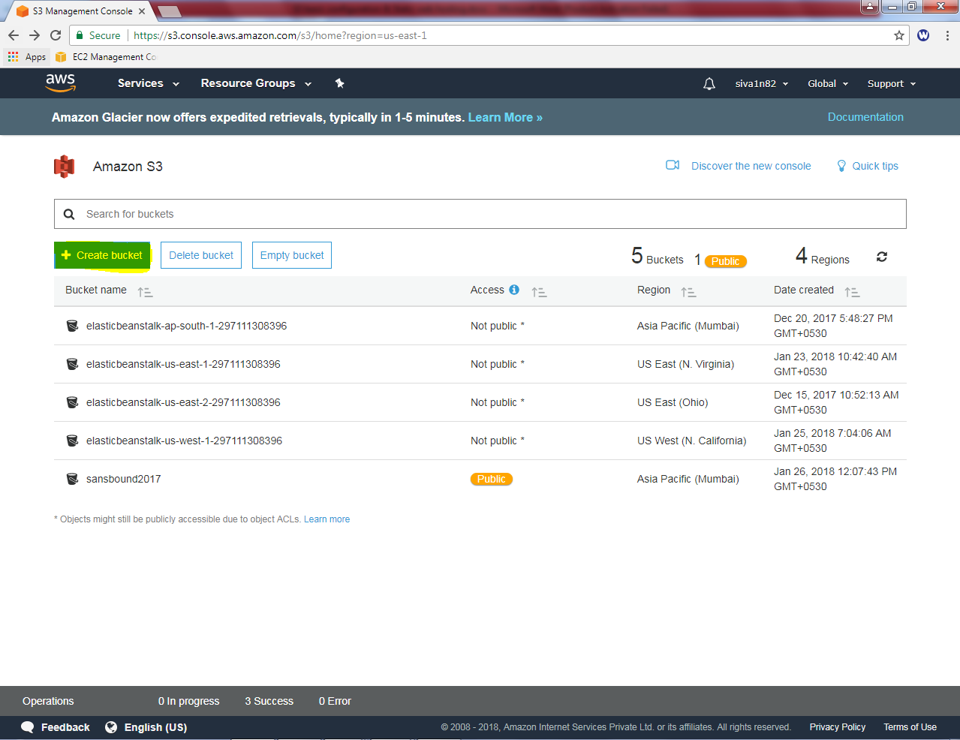

Click “aws.sansbound.com” and click “Next”.

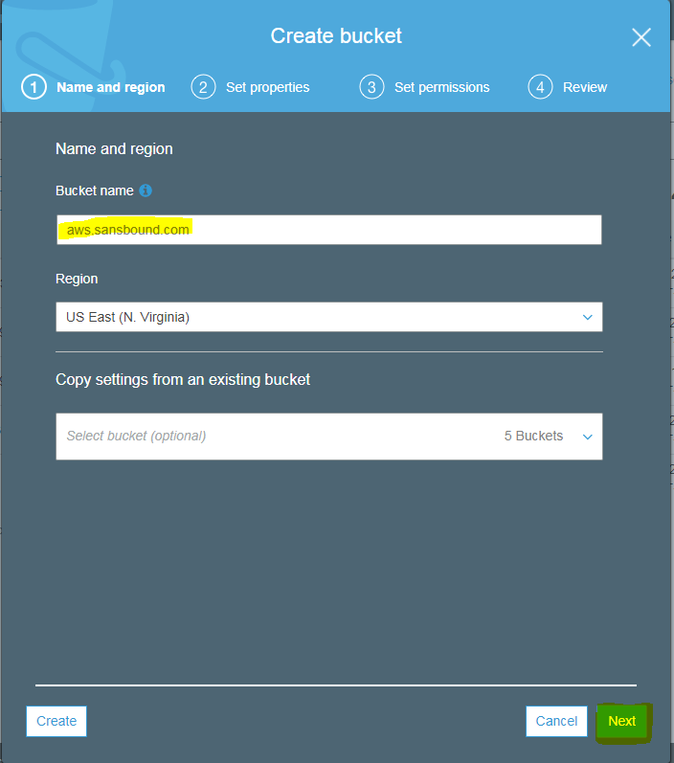

Leave settings by default.

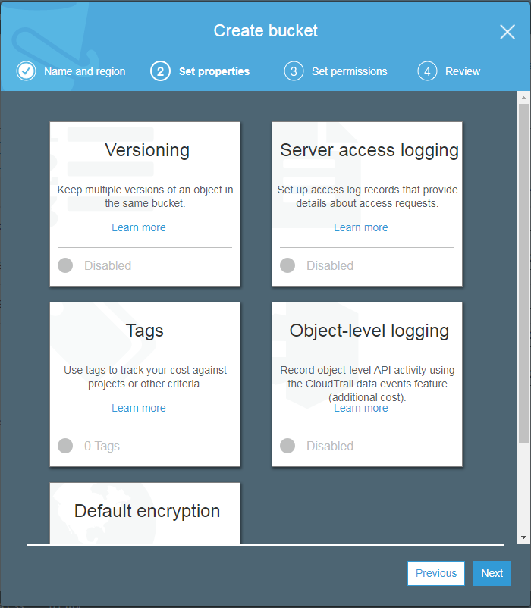

In manage public permissons, click the drop down button and select “Grant public read access to this bucket”.

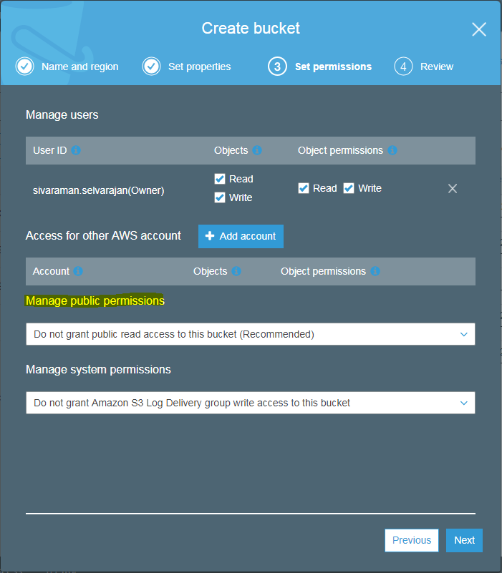

**Click “Next”.**

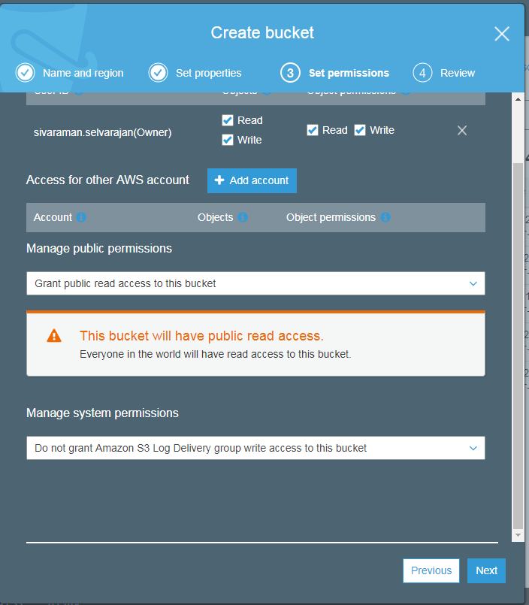

**Click “ Create Bucket”.**

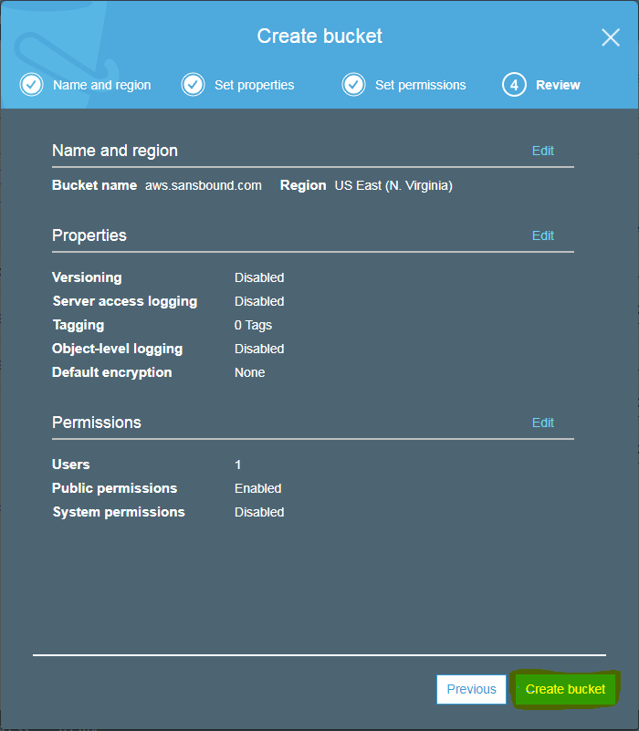

**Click “Upload”.**

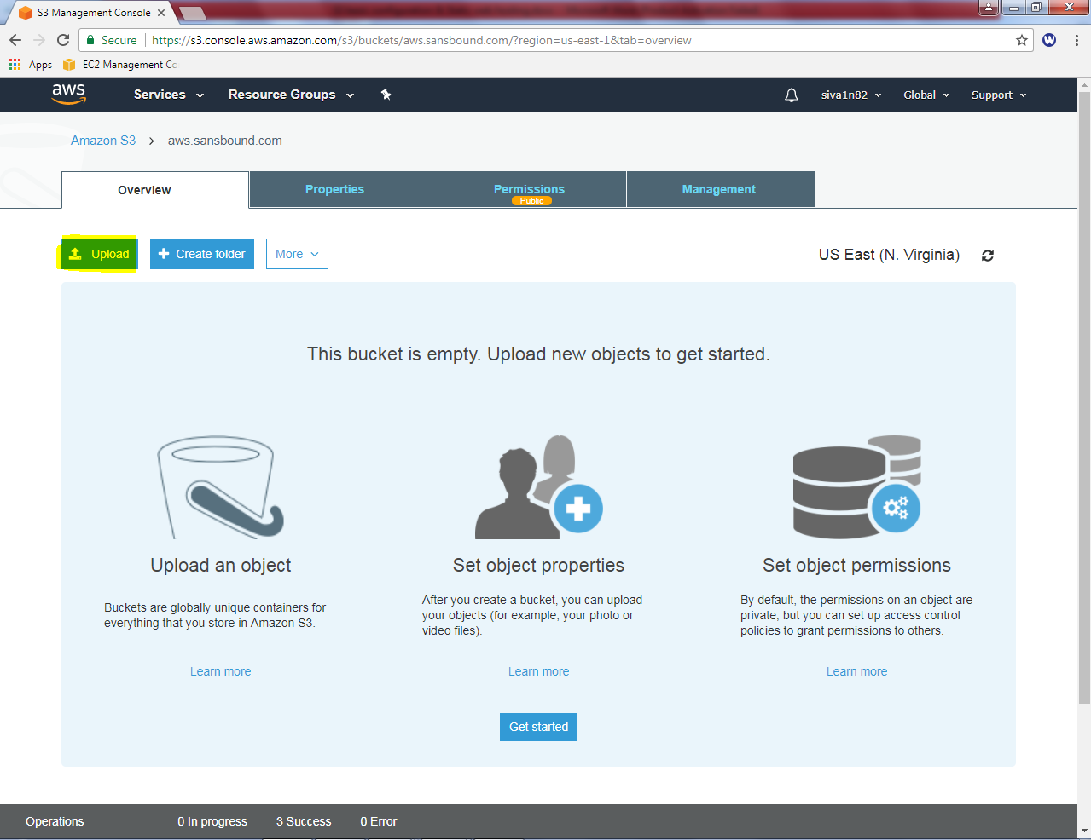

**Click “Add files”.**

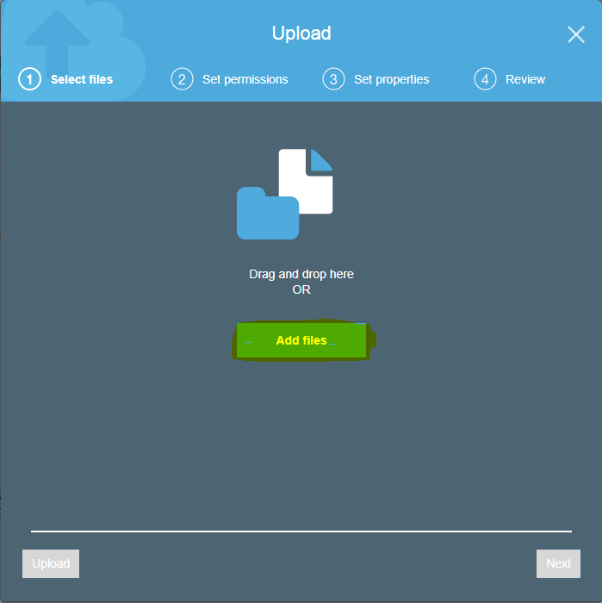

Locate the index.html file and then click “Open”.

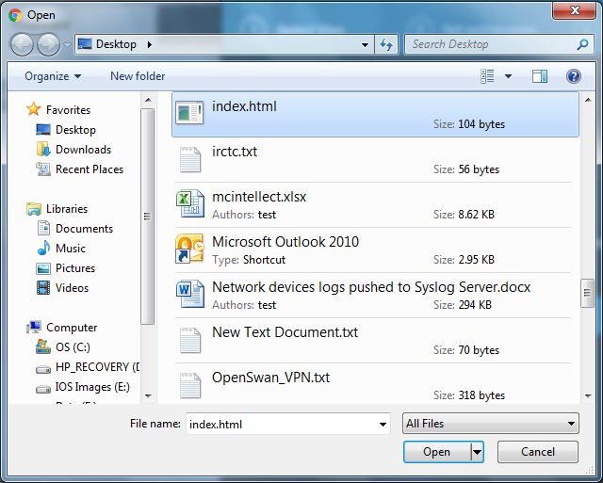

Click “Upload”.

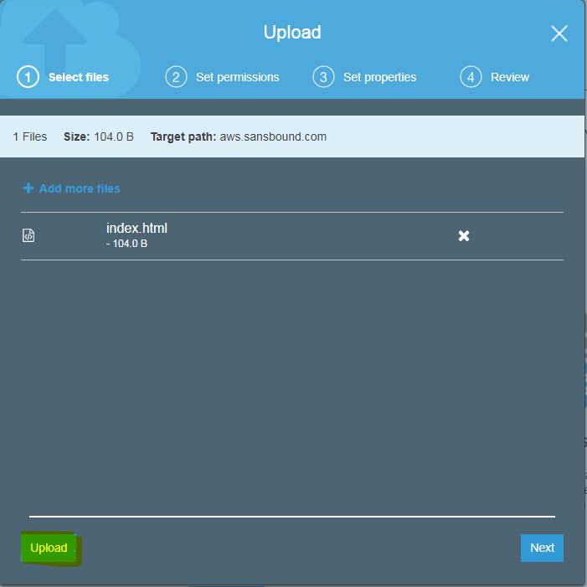

Select the object and Click the “index.html” file

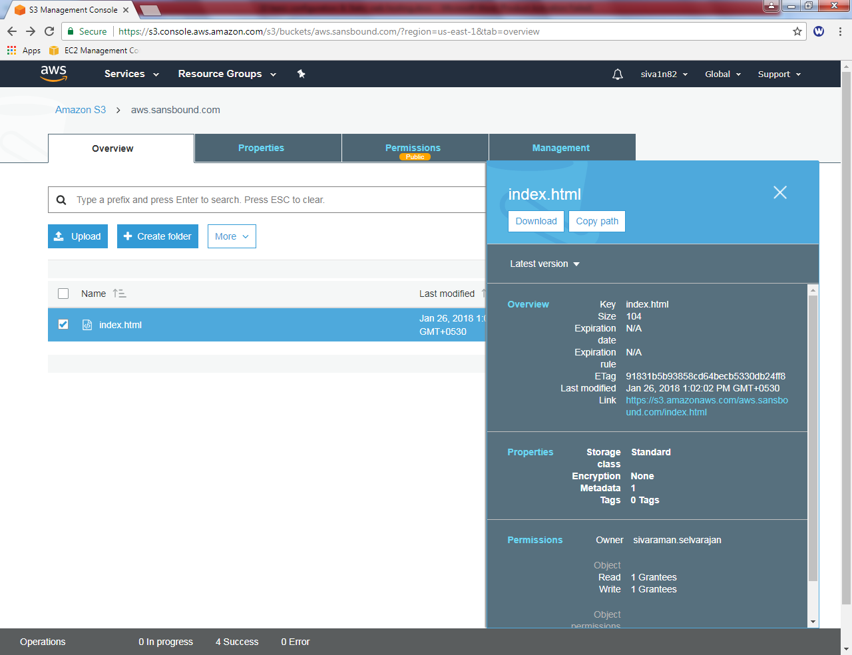

Click “make public” and copy the URL.

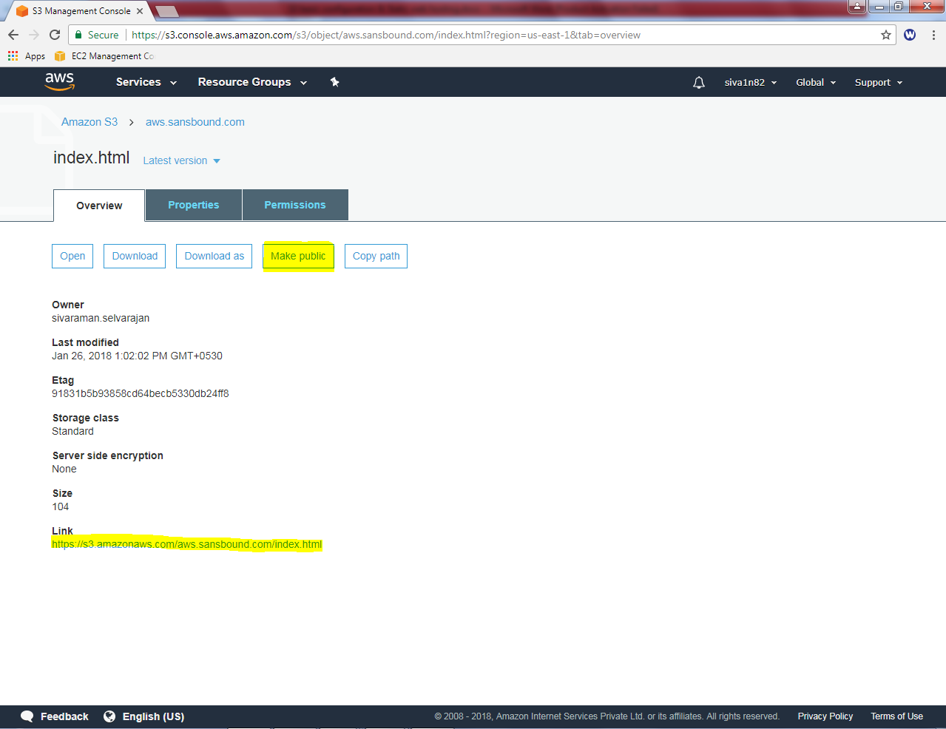

**Now the URL has been successfully maked as Public.**

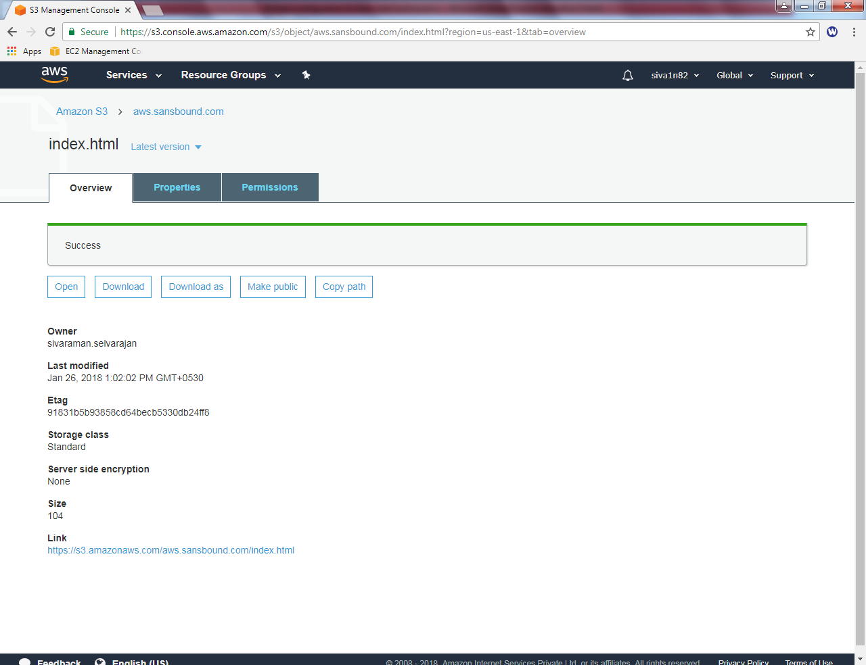

**Click “Static Website hosting”**

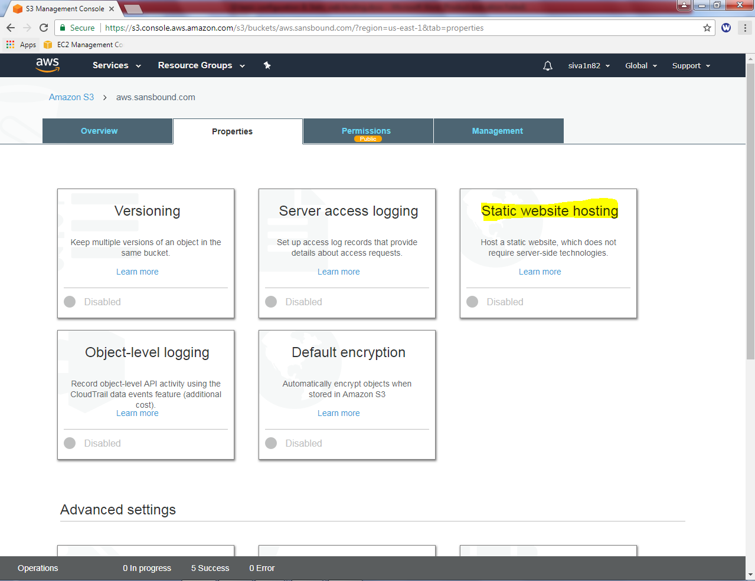

**Click “use this bucket to host a website”. Type the index.html in text box.**

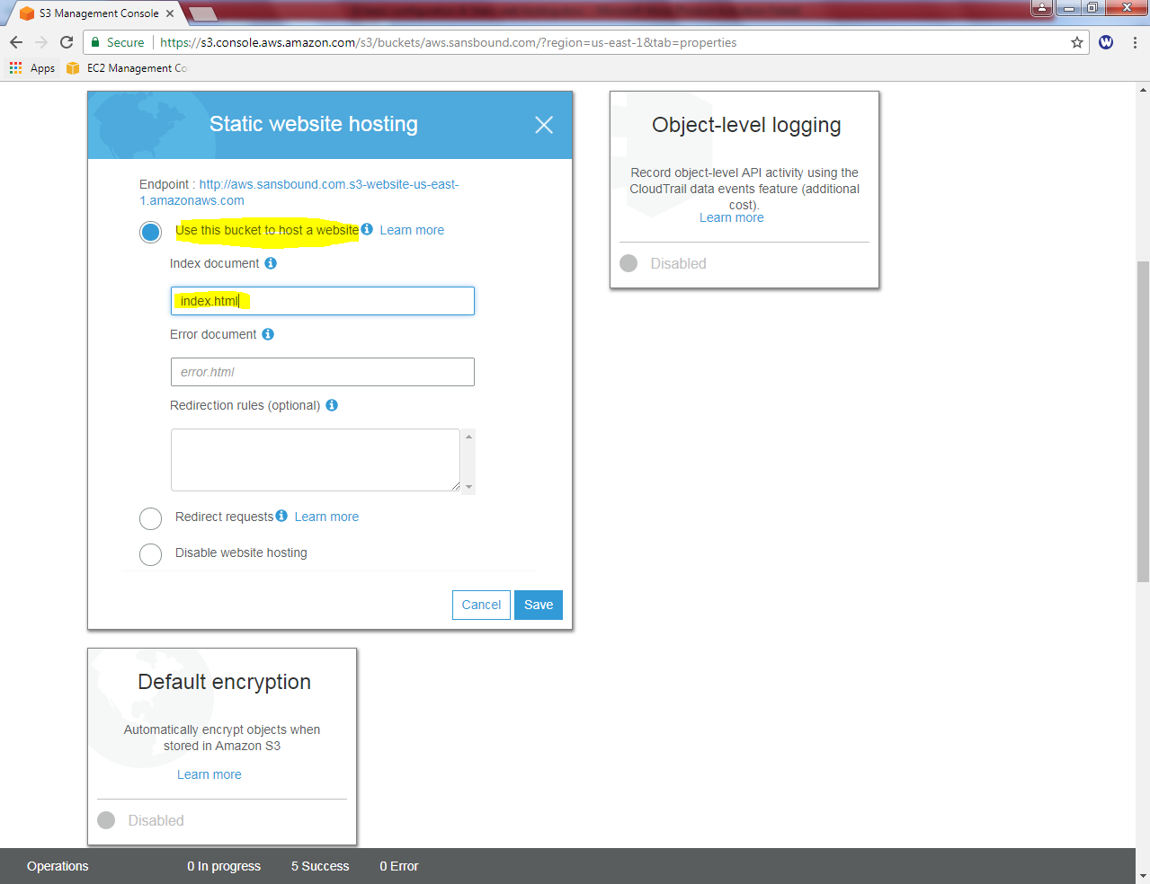

**Then click “save”.**

**Copy the URL from Static websitehosting.**

 http://aws.sansbound.com.s3-website-us-east-1.amazonaws.com

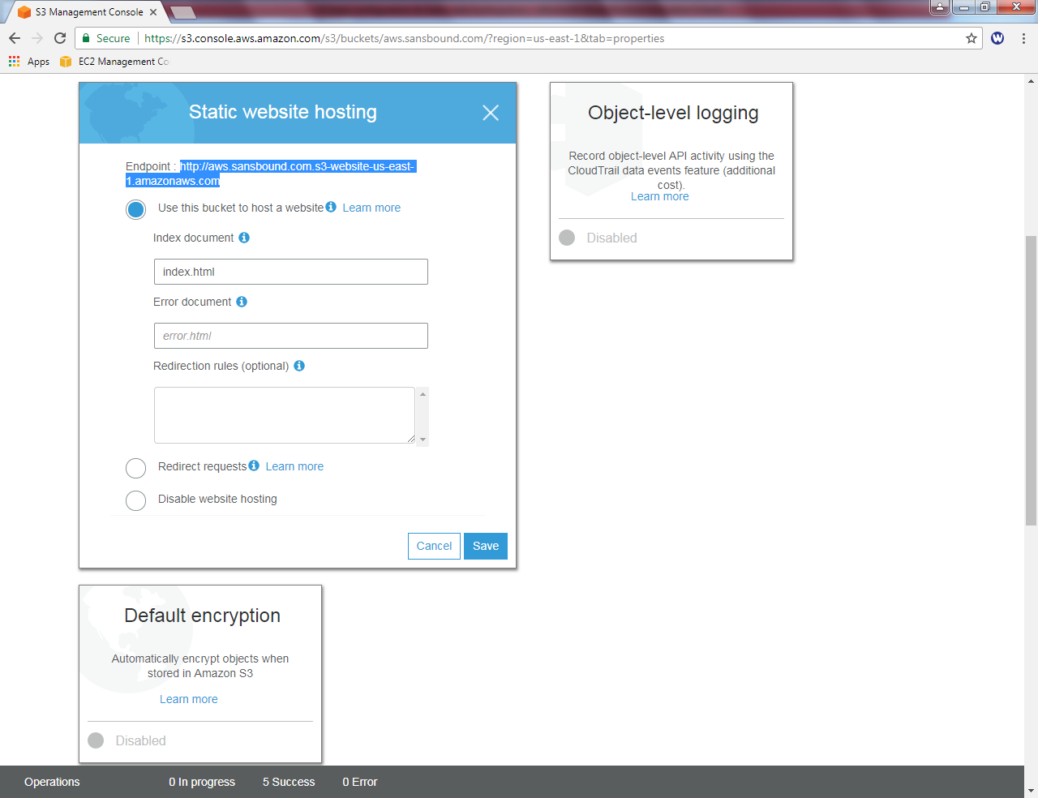

We can able to access the web server successfully.

